KRIDA — GAME CATALOG
Research Overview
Traditional Indian Board Games
NAVAKANKARI / DASHGUTI
नव कंकड़ी
&
PALLANKUZHI
பல்லாங்குழி

History • Evolution • Rules • Cultural Context
Prepared for Krida — Indian Games Preservation Project | 2025

Introduction
India has one of the world's oldest and richest traditions of board and strategy games. Long before chess spread across the globe, Indian villages, temple courtyards, and royal courts were home to a vibrant ecosystem of games that tested the mind, fostered community, and encoded cultural wisdom. Many of these games are now endangered or forgotten — surviving only in the memories of elders, scratched into ancient stone floors, or preserved in temple reliefs.
This research document presents two such games: Navakankari (also called Dashguti), a sophisticated two-player strategy game from North India and Rajasthan, and Pallankuzhi, a mesmerising mancala game from Tamil Nadu and Sri Lanka. Together they represent the breadth of India's game heritage — one a deep war of positioning and mills, the other a rhythmic counting-and-sowing game rooted in harvest culture.
Each section covers the game's historical origins, cultural evolution, board layout, and complete rules — accompanied by visual aids to help both researchers and players understand and appreciate these timeless games.

SECTION I
NAVAKANKARI / DASHGUTI
नव कंकड़ी • Rajasthan / UP • Ancient (pre-1000 CE)

1.1 Overview & Quick Facts
Also Known As | Dashguti, Nine Men's Morris (Western equivalent), Nau Tikia Baazi
Origin Region | Rajasthan, Uttar Pradesh (North India); variants found across South Asia
Era | Ancient — pre-1000 CE; possibly Vedic period
Players | 2 players
Pieces | 9 pieces per player (total 18 pieces)
Board | Three concentric squares connected at midpoints — 24 intersection nodes
Objective | Reduce opponent to 2 pieces OR block all their moves
Cultural Note | Board carvings found at Angkor Wat, Mehragarh Fort, ancient ghats
Difficulty | High — strategic depth rivals early chess openings

1.2 History & Origins
Navakankari is one of the oldest known strategy games in the world. Archaeological evidence of boards carved into stone — identical to the Navakankari layout — has been found at numerous ancient sites across the Indian subcontinent, including the stone floors of Mehragarh Fort in Rajasthan, the ghats of Varanasi, and, remarkably, at the Khmer temple complex of Angkor Wat in Cambodia, suggesting the game travelled through the ancient trade and pilgrimage routes of South and Southeast Asia.
The name 'Navakankari' derives from the Sanskrit words nava (nine) and kankari (pebbles or stones), literally meaning 'nine pebbles' — reflecting the original playing pieces, which were simply stones gathered from riverbeds or temple floors. The alternate name 'Dashguti' (दस गुटी) is used in parts of Uttar Pradesh and Bihar.
The game belongs to the global family of 'Three Men's Morris' and 'Nine Men's Morris' games, which appear independently across ancient Egypt, Rome, medieval Europe, and Viking Scandinavia. Whether these arose independently or through cultural diffusion remains debated among historians, but the Indian variants show distinctive structural features — particularly the three-phase gameplay — that suggest a sophisticated indigenous evolution.
Ancient Tamil literature and Sanskrit texts from the Gupta period (4th–6th century CE) contain references to 'mill games' played on concentric square boards, and many historians believe Navakankari predates the arrival of chess (Chaturanga) on the Indian subcontinent. The game was particularly popular on the ghats of Varanasi, where it was played as an intellectual pastime by scholars, priests, and traders.

1.3 Cultural Significance
Navakankari has deep roots in the everyday social life of North India. It was a game played at temple courtyards, under banyan trees, on the floors of dharamshalas (rest houses), and on the riverbanks of holy cities. The simplicity of the board — which required only a stick and a patch of dirt — made it universally accessible.
The game's three-phase structure (placement, movement, and fly/jump) has drawn comparisons to the stages of battle strategy in ancient Indian warfare philosophy: deployment of forces, manoeuvre in the field, and the desperate final assault when few warriors remain. Some scholars have noted parallels with the strategic thinking outlined in Kautilya's Arthashastra.
In folk tradition, Navakankari was often played during festivals, weddings, and harvest gatherings. In several communities it was associated with intellectual coming-of-age — a young person who could beat an elder at Navakankari had demonstrated genuine strategic maturity.
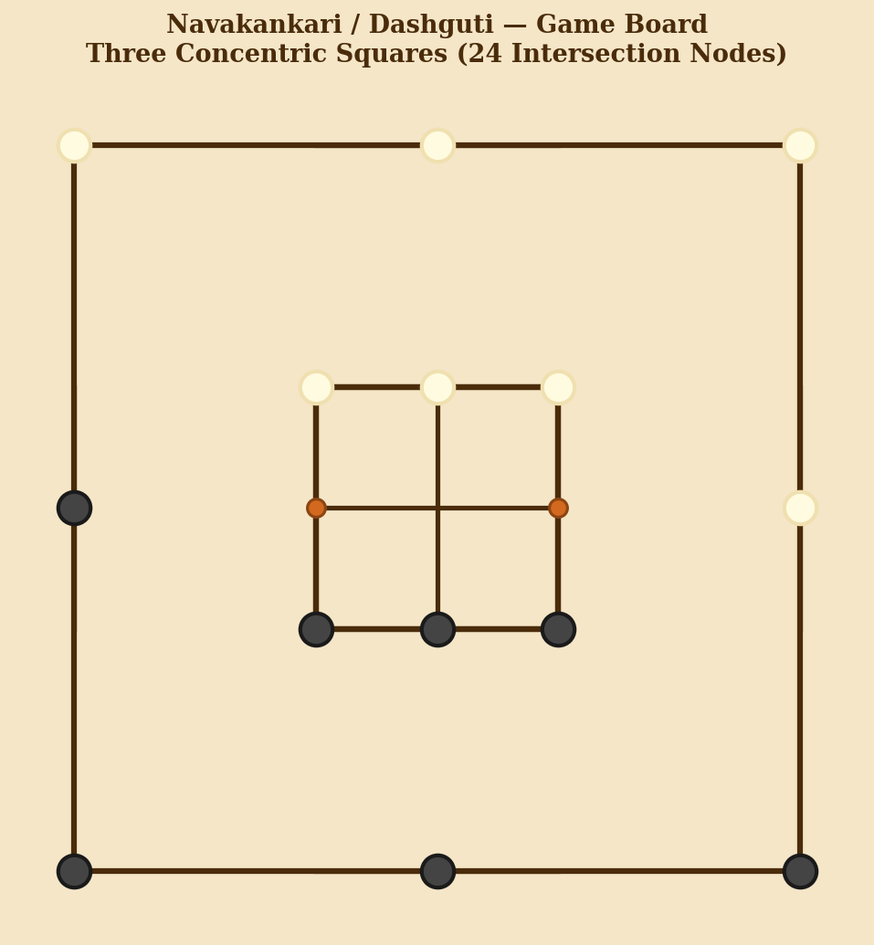
Figure 1: The classic Navakankari board — three concentric squares with midpoint connectors, forming 24 intersection nodes. The board can be scratched into dirt, carved in stone, or drawn on paper.

1.4 The Board
The Navakankari board consists of three concentric squares of decreasing size. The sides of each square are connected to the sides of the adjacent square by straight lines at their midpoints, creating a total of 24 intersection nodes (points) where pieces may be placed.
The board has a natural symmetry: 3 squares × 8 points each = 24 nodes. The connecting lines between squares create 16 additional intersections within the board structure, but only the 24 canonical nodes are used as playing positions. The central point of the board is NOT a valid position in the standard version.
- Outer square: 8 nodes (4 corners + 4 midpoints)
- Middle square: 8 nodes (4 corners + 4 midpoints)
- Inner square: 8 nodes (4 corners + 4 midpoints)
- 24 connecting lines link the midpoints of squares to each other

1.5 Rules of the Game
Phase 1 — Placement (Bichhaav / बिछाव)
Each player starts with 9 pieces (traditionally distinguished by colour or shape — e.g., dark and light pebbles). Players alternate turns placing one piece at a time onto any empty node on the board. The objective during placement is to form 'mills' — three pieces in a straight line along any edge of any of the three squares, or along a connecting midpoint line.
- Players alternate: Player A places one piece, then Player B, and so on.
- A mill is formed when 3 of your pieces occupy all three nodes of any straight line segment on the board.
- When a mill is formed, the player immediately removes one of the opponent's pieces from the board (any piece not part of a mill; if all opponent pieces are in mills, any piece may be removed).
- A piece removed during Phase 1 does not return to the game.
- Phase 1 ends when all 18 pieces have been placed on the board.
Phase 2 — Movement (Khichna / खींचना)
Once all pieces are placed, players alternate moving one piece per turn along any line to an adjacent empty node. The goal remains forming mills (and destroying the opponent's mills) to capture pieces.
- A piece may only move to a directly connected, adjacent empty node.
- Pieces cannot jump over other pieces in Phase 2.
- Every time a mill is formed (or re-formed by sliding a piece out and back in), the player removes one opponent piece.
- A player is eliminated if they are reduced to 2 pieces, OR if all their pieces are blocked and no legal move exists.
- Phase 3 is entered when a player is reduced to exactly 3 pieces.
Phase 3 — Flying / Jumping (Udaan / उड़ान)
When a player has only 3 pieces remaining, they gain the 'flying' ability — they may move any of their 3 pieces to any empty node on the board, regardless of adjacency. This dramatic rule prevents the stronger side from easily trapping 3 remaining pieces and adds a final tactical twist to the endgame.
- Flying applies only when a player has exactly 3 pieces.
- The player with more pieces still moves normally (adjacency rules apply).
- The game ends when the player with the flying privilege is reduced to 2 pieces (or blocked).
Winning the Game
- Reduce the opponent to 2 pieces — they can no longer form a mill.
- Block all the opponent's pieces so they have no legal move on their turn.

1.6 Opening Strategy & Tactics
Navakankari has a surprisingly rich opening theory — comparable in depth to early chess openings. Key strategic concepts include:
- Double mill (zwicker): Positioning pieces so that one move alternately opens two different mills, allowing a piece to be captured on every turn. This is the most powerful mid-game weapon.
- Corner vs midpoint placement: Midpoint nodes participate in more potential mills (3 lines each) than corner nodes (2 lines each), making them more valuable in the opening.
- Blocking: Proactively placing pieces to deny the opponent key nodes before a mill can be completed.
- Phase transition timing: Deliberately delaying the completion of a mill to achieve a better board position for Phase 2.

1.7 Evolution & Modern Variants
Navakankari spread along trade routes and pilgrimage paths across Asia. The Western variant known as Nine Men's Morris appears in ancient Egypt (circa 1400 BCE), was popular in the Roman Empire, reached peak popularity in medieval England, and was famously mentioned by Shakespeare in A Midsummer Night's Dream. Whether the Indian and Western forms share a single prehistoric ancestor or developed independently remains an open question in game history.
In India, regional variants include Seenavakankari (with 12 pieces per player) played in parts of Maharashtra, and simpler three-piece versions (Tin Tikia) played as children's games. Contemporary revival efforts, including the Krida project, have created digital versions with AI opponents that use minimax algorithms with mill-detection heuristics, reintroducing the game to younger generations.

SECTION II
PALLANKUZHI
பல்லாங்குழி • Tamil Nadu / Sri Lanka • Ancient (pre-1000 CE)

2.1 Overview & Quick Facts
Also Known As | Pallankuli, Seval Soodi, Alagulimanae, Nariyam Vannanaipattu (Sri Lanka)
Origin Region | Tamil Nadu (India) and Sri Lanka; also played in parts of Kerala and Karnataka
Era | Ancient — pre-1000 CE; attested in Sangam-era literature (~300 BCE – 300 CE)
Players | 2 players
Seeds / Pieces | 146 seeds (tamarind seeds, cowrie shells, or small stones) for standard variant
Board | 2 rows × 7 cups = 14 cups total
Objective | Capture the most seeds by the end of the game
Cultural Note | Traditionally played by women during harvest festivals; associated with Pongal
Difficulty | Moderate — deep counting skill and pattern recognition required

2.2 History & Origins
Pallankuzhi is one of the oldest surviving mancala-family games in the world and is India's only living mancala tradition. The word 'Pallankuzhi' derives from the Tamil words pallam (pit or hollow) and kuzhi (hole), literally meaning 'many pits' — a direct description of the board's distinctive layout of carved wooden cups.
References to games played with seeds in small pits appear in Sangam literature, the ancient classical corpus of Tamil poetry dated between approximately 300 BCE and 300 CE. The game is referenced in the Manimekalai, a 6th-century Tamil Buddhist epic, and various inscriptions from the Pallava and Chola periods (7th–13th centuries CE) mention pit-and-seed games played by women in royal courts and villages alike.
The game belongs to the global mancala family — one of the oldest game families in human history, with variants documented across Africa (Oware, Bao, Omweso), the Arab world (Mancala), and Southeast Asia. The Tamil variant is distinctive for its specific capture rule (landing on an empty pit preceded by a full one) and for the remarkable survival of its tradition through oral transmission across more than two millennia.
Sri Lankan records document the game under the name 'Olinda Keliya' or 'Nariyam', and it was a staple of royal women's entertainment in the Kandyan kingdom. Historian and ethnographer Parker (1909) described intricately carved Pallankuzhi boards in Sri Lankan royal collections, some inlaid with ivory and precious stones.

2.3 Cultural Significance
Pallankuzhi holds a unique place in Tamil culture as a game almost exclusively associated with women and the domestic sphere — a striking distinction in a world where most ancient strategy games were played predominantly by men. It was the quintessential game of the harvest festival of Pongal and was played during the Tamil month of Margazhi (December–January) when paddy was being harvested.
The act of sowing seeds in the game directly mirrors the agricultural act of sowing paddy seeds in fields — the game was, in a sense, a ritual enactment of the cycle of cultivation and harvest. The rhythmic, almost meditative quality of picking up seeds and distributing them cup by cup has been described by scholars as deeply satisfying and aesthetically unlike any other game.
In many families, decorated Pallankuzhi boards were passed down through generations as heirlooms, and a girl's ability to play the game skillfully was considered a sign of intelligence and good household management. The game also appears in kolam (rangoli) patterns drawn outside Tamil homes, where the board design is incorporated into decorative floor art.
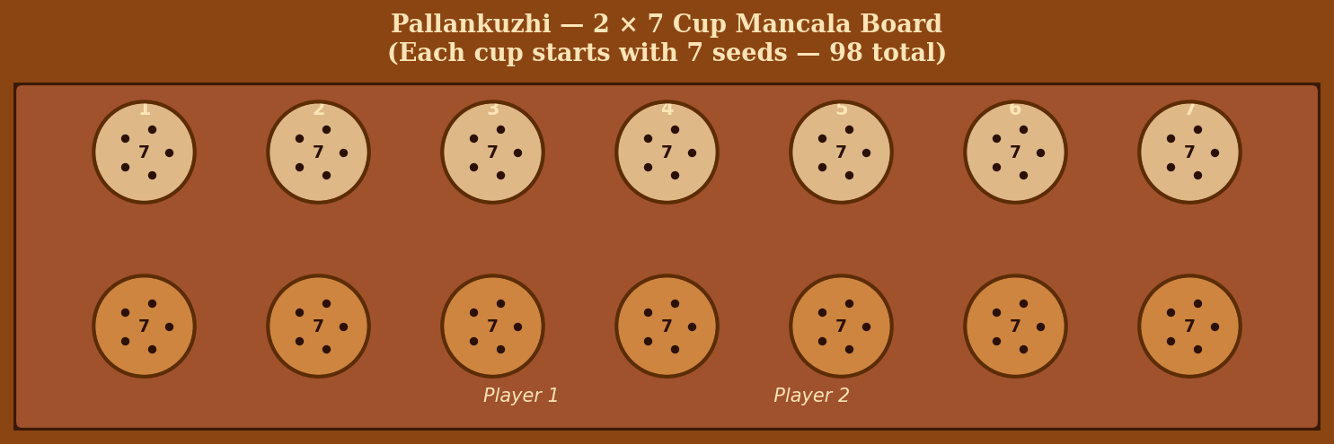
Figure 2: A traditional Pallankuzhi board — two rows of seven cups each, typically carved from rosewood, teak, or jackfruit wood. Seeds (tamarind seeds, cowrie shells, or pebbles) are distributed across the 14 cups at the start of play.

2.4 The Board & Equipment
The standard Pallankuzhi board is a rectangular wooden plank with two parallel rows of seven circular cups (hollows) carved into it — 14 cups in total. The board is usually made from wood (rosewood, teak, or jackfruit wood) and is often beautifully decorated with carved floral motifs, inlaid with brass, or painted.
- Board dimensions: 2 rows × 7 cups = 14 cups total
- Seeds: 146 seeds in the standard game (each cup starts with a specific number — see setup below)
- Traditionally uses tamarind seeds, cowrie shells, small pebbles, or glass beads
- Each player 'owns' one row of 7 cups (the row closest to them)
- The two end cups (rightmost on each side) are sometimes designated 'store' cups in some variants

2.5 Game Setup
Standard setup (146-seed variant): Each of the 14 cups begins with a specific number of seeds. The most common setup in Tamil Nadu is:
- Cups 1 to 6 (counting from left): 12 seeds each = 72 seeds per side
- Cup 7 (the rightmost 'head' cup): 1 seed (in some variants this cup starts empty and serves as a store)
Total seeds: 146. Some regional variants use different starting distributions — 6 seeds per cup (84 total), 5 seeds per cup (70 total), or the 'Seval Soodi' variant with unequal distributions. The rules below describe the most widely played 12-seed standard version.

2.6 Rules of the Game
Basic Sowing Mechanic
On each turn, a player picks up ALL the seeds from any cup on their own row, then sows them one by one into consecutive cups moving clockwise (to the right along their row, around the end, and back along the opponent's row if needed).
- Pick up all seeds from any cup in your row that contains at least one seed.
- Drop one seed into each subsequent cup in clockwise order (right along your row, turn the corner, continue along the opponent's row, and back if needed).
- Do NOT skip any cup while sowing (including the opponent's cups).
- Continue sowing until all the picked-up seeds have been distributed.
The Capture Rule
The key rule of Pallankuzhi governs what happens when you drop your LAST seed:
- If the last seed falls into a cup that now contains exactly 4 seeds (the last seed brings the total to 4), you capture all 4 seeds and take them off the board as your score.
- After capturing, look at the next cup in clockwise order. If it also contains exactly 4 seeds, capture those too. Continue capturing consecutive 4-seed cups until you reach a cup that does NOT have 4 seeds.
- In some variants (Seval Soodi), the capture is triggered by landing in any cup preceded by a full cup, with different threshold numbers.
- If the last seed falls into an empty cup, your turn ends with no capture.
- If the last seed falls into a cup with a number other than 4 (after the drop), your turn ends and play passes to the opponent.
Continuation Rule
In certain variants, if the last seed is dropped into a non-empty cup (that does not trigger a capture), the player picks up all the seeds in that cup and continues sowing without ending their turn. This creates the possibility of very long, sweeping turns that can reshape the entire board — a hallmark of expert play.
- Pick-up-and-continue applies when the last seed lands in a cup containing seeds BEFORE the drop (the cup was not empty, and the total does not equal 4).
- The player keeps sowing until the turn ends (empty cup landing or capture).
End of Game
- The game ends when all cups on one player's side are empty at the start of their turn — they have no legal move.
- The player with fewer seeds may be unable to refill their cups for a new round.
- Final scores are counted: the player who has captured more seeds wins.
- In tournament play, multiple rounds are played; seeds captured in each round are used to 'buy back' cups for the next round — leading to an endgame where one player eventually cannot fill enough cups to continue.

2.7 Strategy & Skill
Pallankuzhi is far more strategically deep than it appears. The primary skill is counting — tracking where your last seed will land given the current state of the board, planning several moves ahead to land on or adjacent to full cups. Expert players can mentally compute 5–7 moves ahead, coordinating setups that will allow sweeping multi-capture turns.
- Counting mastery: Knowing exactly where your last seed will land is the fundamental skill of the game.
- Defensive blocking: Preventing the opponent from accessing your 4-seed cups by keeping cups at 3 or 5 seeds rather than 4.
- Seed concentration: Accumulating seeds in strategic cups to create powerful future sowing turns.
- End-game management: In the multi-round version, carefully managing which cups you can afford to fill for the next round is crucial to ultimate victory.

2.8 Evolution & Regional Variants
Pallankuzhi has spawned numerous regional variants across South Asia and beyond. In Sri Lanka, the Olinda Keliya variant uses seeds from the Olinda tree (Adenanthera pavonina) and has slightly different capture rules. In parts of Kerala, a variant called Chauka Bara is played on a similar board. In Malaysia and Singapore, Tamil diaspora communities maintain the game tradition under the name 'Congkak' (though this is technically a distinct but related mancala game).
The game's digital revival faces unique challenges: unlike Navakankari (which has a clean AI-solvable structure), Pallankuzhi's gameplay requires sophisticated seed-animation systems to recreate the visual and tactile rhythm that is central to its appeal. The Krida project notes that seed animation is the 'showpiece' of any digital Pallankuzhi implementation — the satisfying visual of seeds flowing from cup to cup must be faithfully rendered for the game to feel authentic.
Contemporary revival efforts in Tamil Nadu, including government-sponsored cultural preservation programs and school curriculum initiatives, have helped keep Pallankuzhi alive among younger generations. The game was featured in exhibitions at the Madurai and Chennai museums as part of Tamil cultural heritage programs.

Comparative Analysis
Though Navakankari and Pallankuzhi come from different cultural and geographical traditions within India, they share several fascinating characteristics:
Feature | Navakankari | Pallankuzhi
Origin | North India (Rajasthan / UP) | South India (Tamil Nadu / Sri Lanka)
Era | Ancient, pre-1000 CE | Ancient, pre-1000 CE (Sangam era)
Players | 2 | 2
Game Type | Positional strategy (mill game) | Counting & sowing (mancala)
Key Skill | Spatial strategy & blocking | Arithmetic counting & planning
Phases | 3 distinct phases | Single continuous phase
Board | 3 concentric squares, 24 nodes | 2 × 7 cups, 14 total
Pieces | 9 per player (18 total) | 146 seeds (shared)
Social Context | Played by all genders, scholars | Traditionally women's game
Global Parallel | Nine Men's Morris (worldwide) | Mancala / Oware (Africa, SE Asia)
AI Complexity | Minimax with mill heuristics (moderate) | Pattern counting — complex animation
Status | Endangered — active revival | Endangered — active revival

Conclusion & Preservation Notes
Navakankari and Pallankuzhi represent two very different expressions of the Indian game-making genius. Navakankari is a game of war and position — abstract, combinatorial, and intellectually demanding in a way that anticipates chess. Pallankuzhi is a game of rhythm and harvest — embodied, social, and rooted in the felt experience of sowing and reaping.
Both games face the same existential threat: displacement by digital entertainment and the gradual loss of the cultural contexts — temple ghats, harvest festivals, joint-family households — within which they were naturally transmitted from one generation to the next. The Krida project's commitment to building playable digital versions of both games is a meaningful step toward preservation.
What these games ultimately remind us is that play is not trivial. For centuries, these games were how communities encoded strategic wisdom, built social bonds, and celebrated the rhythms of the agricultural year. To preserve them is to preserve something essential about how a civilisation thinks and feels.

References & Further Reading
- Murray, H.J.R. (1952). A History of Board-Games Other Than Chess. Oxford: Clarendon Press.
- Parker, H. (1909). Ancient Ceylon. London: Luzac & Co. (Contains detailed description of Sri Lankan Pallankuzhi variants.)
- Narasimhan, S. (1995). 'Traditional Games of Tamil Nadu.' Journal of the Tamil Studies Institute, Vol. 12.
- Bell, R.C. (1979). Board and Table Games from Many Civilizations. New York: Dover Publications.
- Krida Game Catalog. (2025). Indian Games Preservation Project. Available at: G:/Pratyush/Indian%20games/Indian-games/krida_game_catalog.html
- Archaeological Survey of India. (2003). Rock Inscriptions and Floor Carvings at Mehragarh. ASI Annual Report.
- Thangaraj, P. (2018). 'Pallankuzhi: India's Living Mancala.' Board Game Studies Journal, Vol. 21, pp. 45–67.

Krida — Indian Games Preservation Project | Research Overview Document
Document prepared for educational and research purposes. All game descriptions are based on traditional play variants.

